**Ball and Beam Experiment Report – MyRIO version**

**Experiment Result**

1. **Calibration**

**(1) Position**

|  |  |  |  |  |  |
| --- | --- | --- | --- | --- | --- |
| Position | -30 | -10 | 0 | 10 | 30 |
| Voltage | 5.97 | 5.02 | 4.54 | 4.07 | 3.11 |
| $Position=a×Volt+b$ $⟹$ a= -20.986 b= 95.319 | | | | | | |

**(2) Angle**

$V_{0}= 3.32 { V}_{-10}=$ 3.04

$Angle=a×Volt+b$ $⟹$ a= 35.714 b= -118.57

**2. Beam Angle Control**

(1) Desired angle is 0. Please Record the Steady-error and the data in different $K_{p1}$

|  |  |  |  |  |  |  |
| --- | --- | --- | --- | --- | --- | --- |
| $$K_{p1}$$ | 1 | 3 | 5 | 7 | 15 | 20 |
| Steady-error | 0.163 | 0.012 | 0.0116 | 0.0116 | 0.75震盪 | 1.2 震盪 |

(2)Data Plot

$$K_{p1}=1$$

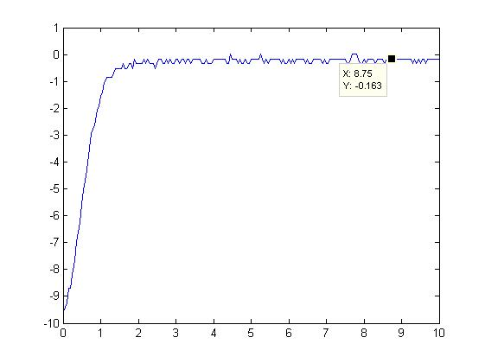

$$K_{p1}=3$$

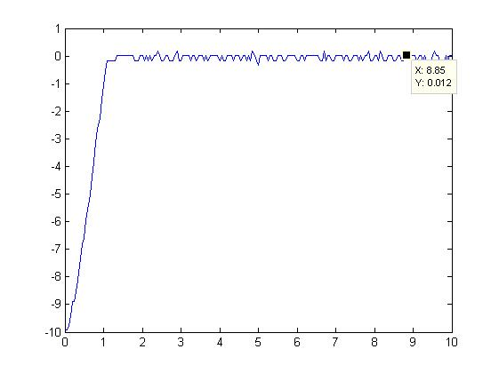

$$K_{p1}=5$$

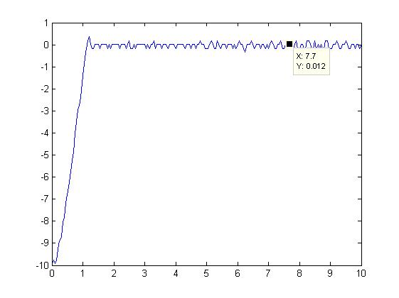

$$K_{p1}=7$$

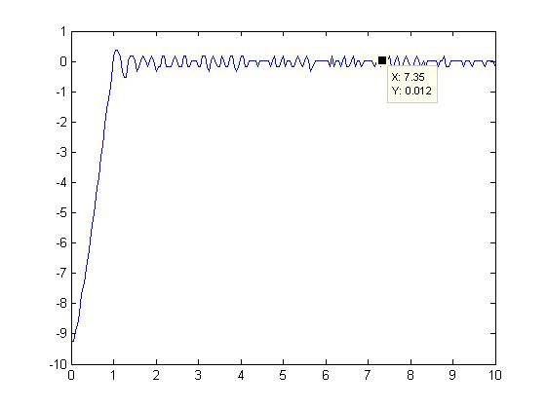

$K_{p1}=1$ 5

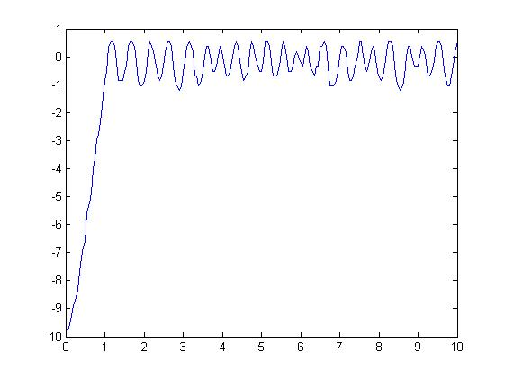

$$K_{p1}=20$$

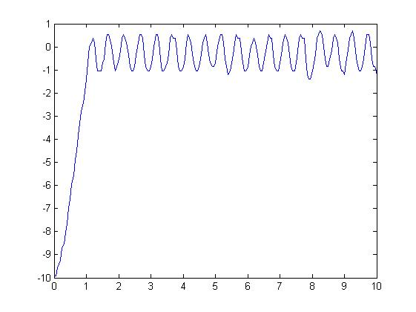

**3. BALL AND BEAM EXPERIMENT - PART I**

(1) Find the parameter $K_{p},K_{d}$ of the control ,with different damping ratio  and natural frequency $ω_{n}$

|  |  |  |
| --- | --- | --- |
|  |  |  |
|  | 0.918 | 0.612 |
|  | 0.102 | 0.144 |
|  | 0.918 | 0.433 |
|  | 0.102 | 0.102 |
|  | 0.918 | 0.306 |



(2) Desired position is 0 cm. Set up all the parameter and plot the performance data.

$$K_{p}=0.918 { K}_{d}=0.612$$

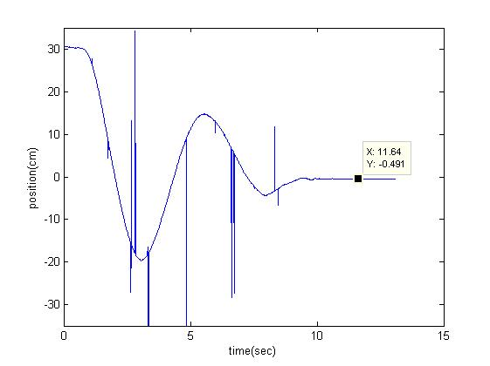

$$K_{p}=0.102 { K}_{d}=0.144$$

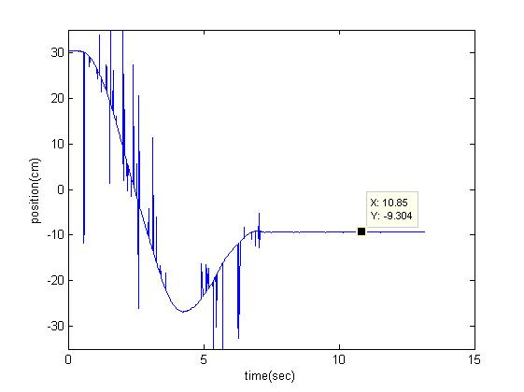

$$K_{p}=0.918 { K}_{d}=0.433$$

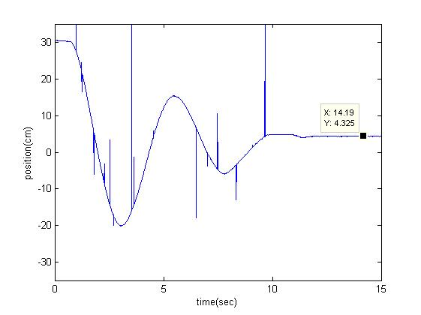

$$K_{p}=0.102 { K}_{d}=0.102$$

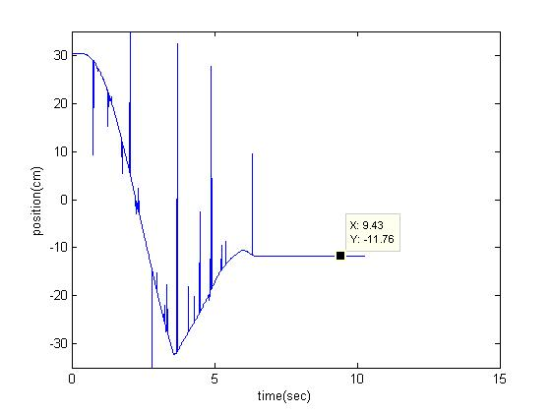

$$K_{p}=0.918 { K}_{d}=0.306$$

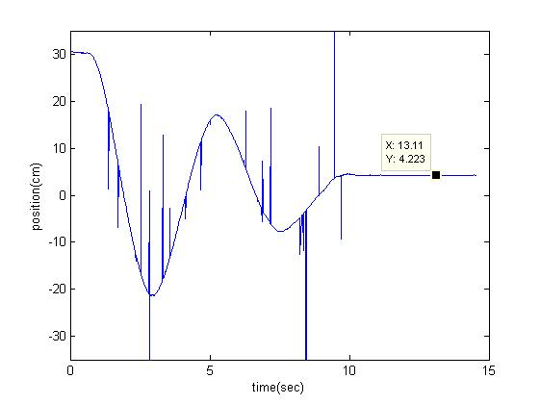

**4. BALL AND BEAM EXPERIMENT - PART II**

(1) Find the parameter $K_{p},K_{d},K_{i}$ of the control ,with different damping ratio $ξ$ and natural frequency $ω_{n}$, decay rate a

|  |  |  |  |  |  |
| --- | --- | --- | --- | --- | --- |
|  |  |  |  |  |  |
| 1 | 3 | 10 | 0.574 | 16 | 0.440 |
| 0.707 | 3 | 10 | 0.6448 | 14.242 | 0.368 |
| 0.707 | 3 | 20 | 0.7577 | 24.242 | 0.395 |
| 0.5 | 3 | 20 | 0.7986 | 23 | 0.306 |



(2) Desired position is 0 cm. Set up all the parameter and plot the performance data.

$$K_{p}=0.574 { K}_{i}=16 K_{d}=0.440$$

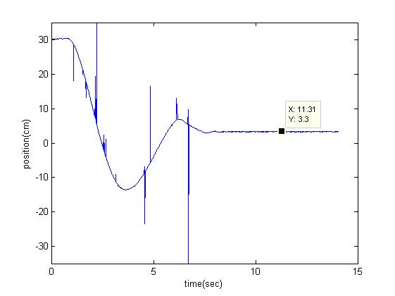

$$K_{p}=0.6448 { K}_{i}=14.242 K_{d}=0.368$$

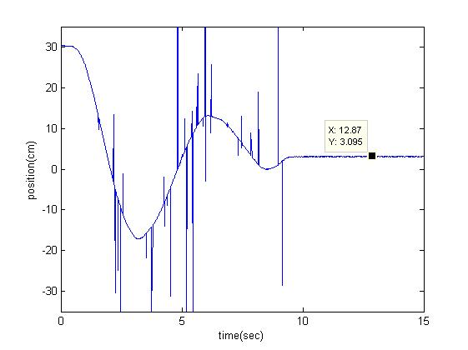

$$K_{p}=0.7577 { K}_{i}=24.242 K_{d}=0.395$$

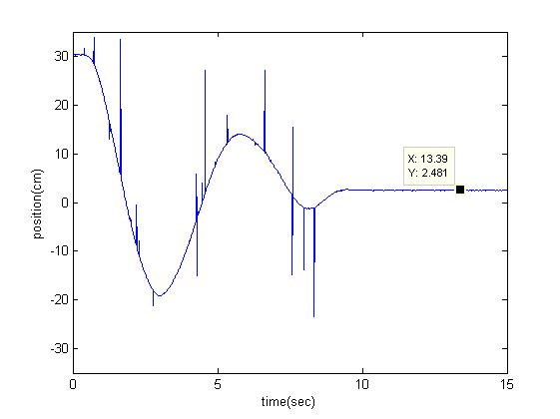

$$K_{p}=0.7986 { K}_{i}=23 K_{d}=0.3061$$

